How to install and remove fonts on your Mac
Your Mac comes with many built-in fonts, and you can download and install more from Apple and other sources. If you don't want a font to appear in your apps, you can disable or remove it.

Install fonts
Double-click the font in the Finder, then click Install Font in the font preview window that opens. After your Mac validates the font and opens the Font Book app, the font is installed and available for use.
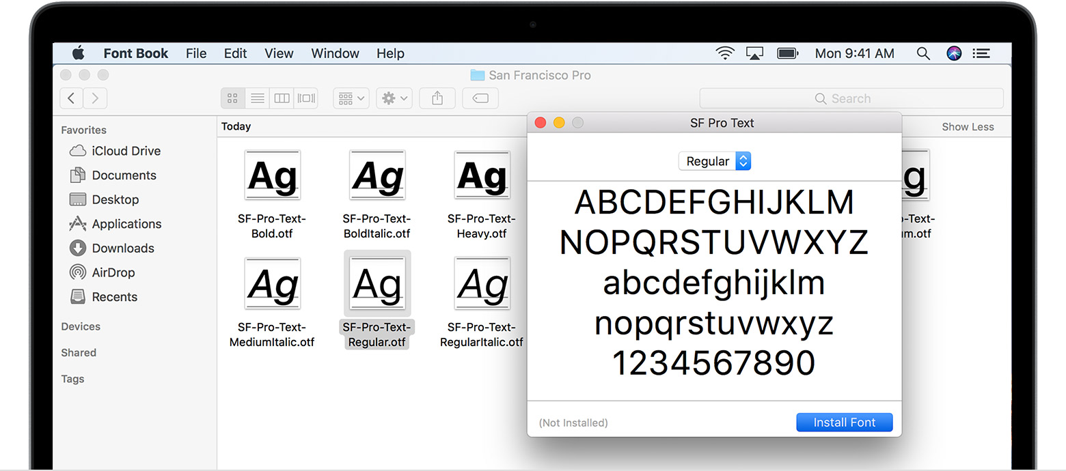
You can use Font Book preferences to set the default install location, which determines whether the fonts you add are available to other user accounts on your Mac.
Fonts that appear dimmed in Font Book are either disabled ("Off"), or are additional fonts available for download from Apple. To download the font, select it and choose Edit > Download.
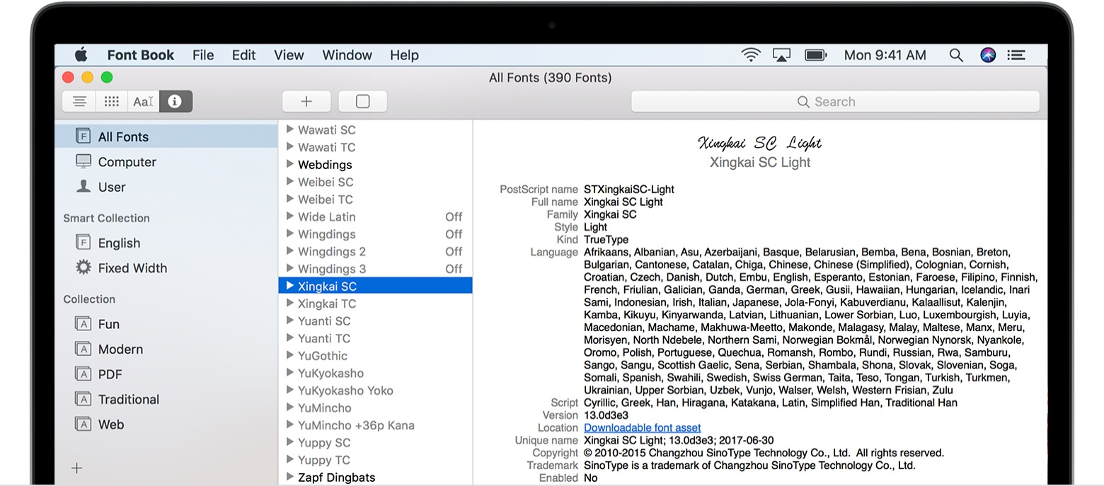

Disable fonts
You can disable any font that isn't required by your Mac. Select the font in Font Book, then choose Edit > Disable. The font remains installed, but no longer appears in the font menus of your apps. Fonts that are disabled show ”Off” next to the font name in Font Book.
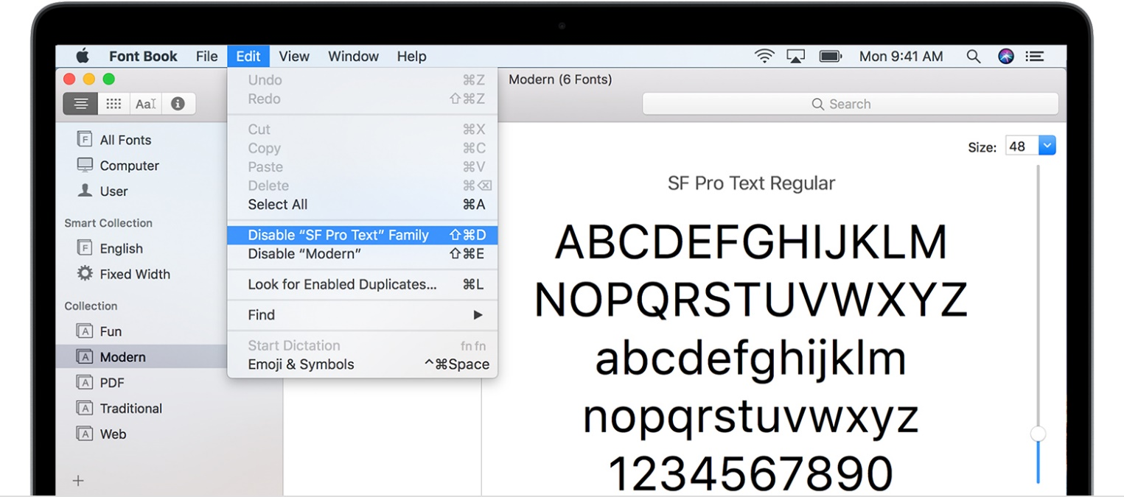

Remove fonts
You can remove any font that isn't required by your Mac. Select the font in Font Book, then choose File > Remove. Font Book moves the font to the Trash.

Learn more
macOS supports TrueType (.ttf), Variable TrueType (.ttf), TrueType Collection (.ttc), OpenType (.otf), and OpenType Collection (.ttc) fonts. macOS Mojave adds support for OpenType-SVG fonts.

